NORTHEAST W ISC O NSIN

**empowHER**

Tradeswomen Meet and Greet

# Tuesday, November 12th, 2024

Evening Celebration Event 4-6pm

## Plumbers & Steamﬁtters

**UA Local 400**

### 2700 Northridge Dr

Kaukauna, WI 54130

Potential & Current Tradeswomen Welcome Round Table Discussion to begin at 4 pm

Food | Refreshments | Door Prizes

FREE CHILDCARE WILL BE PROVIDED

**SAVE THE DATE**

# Tuesday

**NOVEMBER 12**

# 2024

**RSVP Appreciated by November 1, 2024** but Walk-In’s Welcome. RSVP Link: **https://forms.oﬃce.com/r/yQHxC7xbNN** or scan QR Code

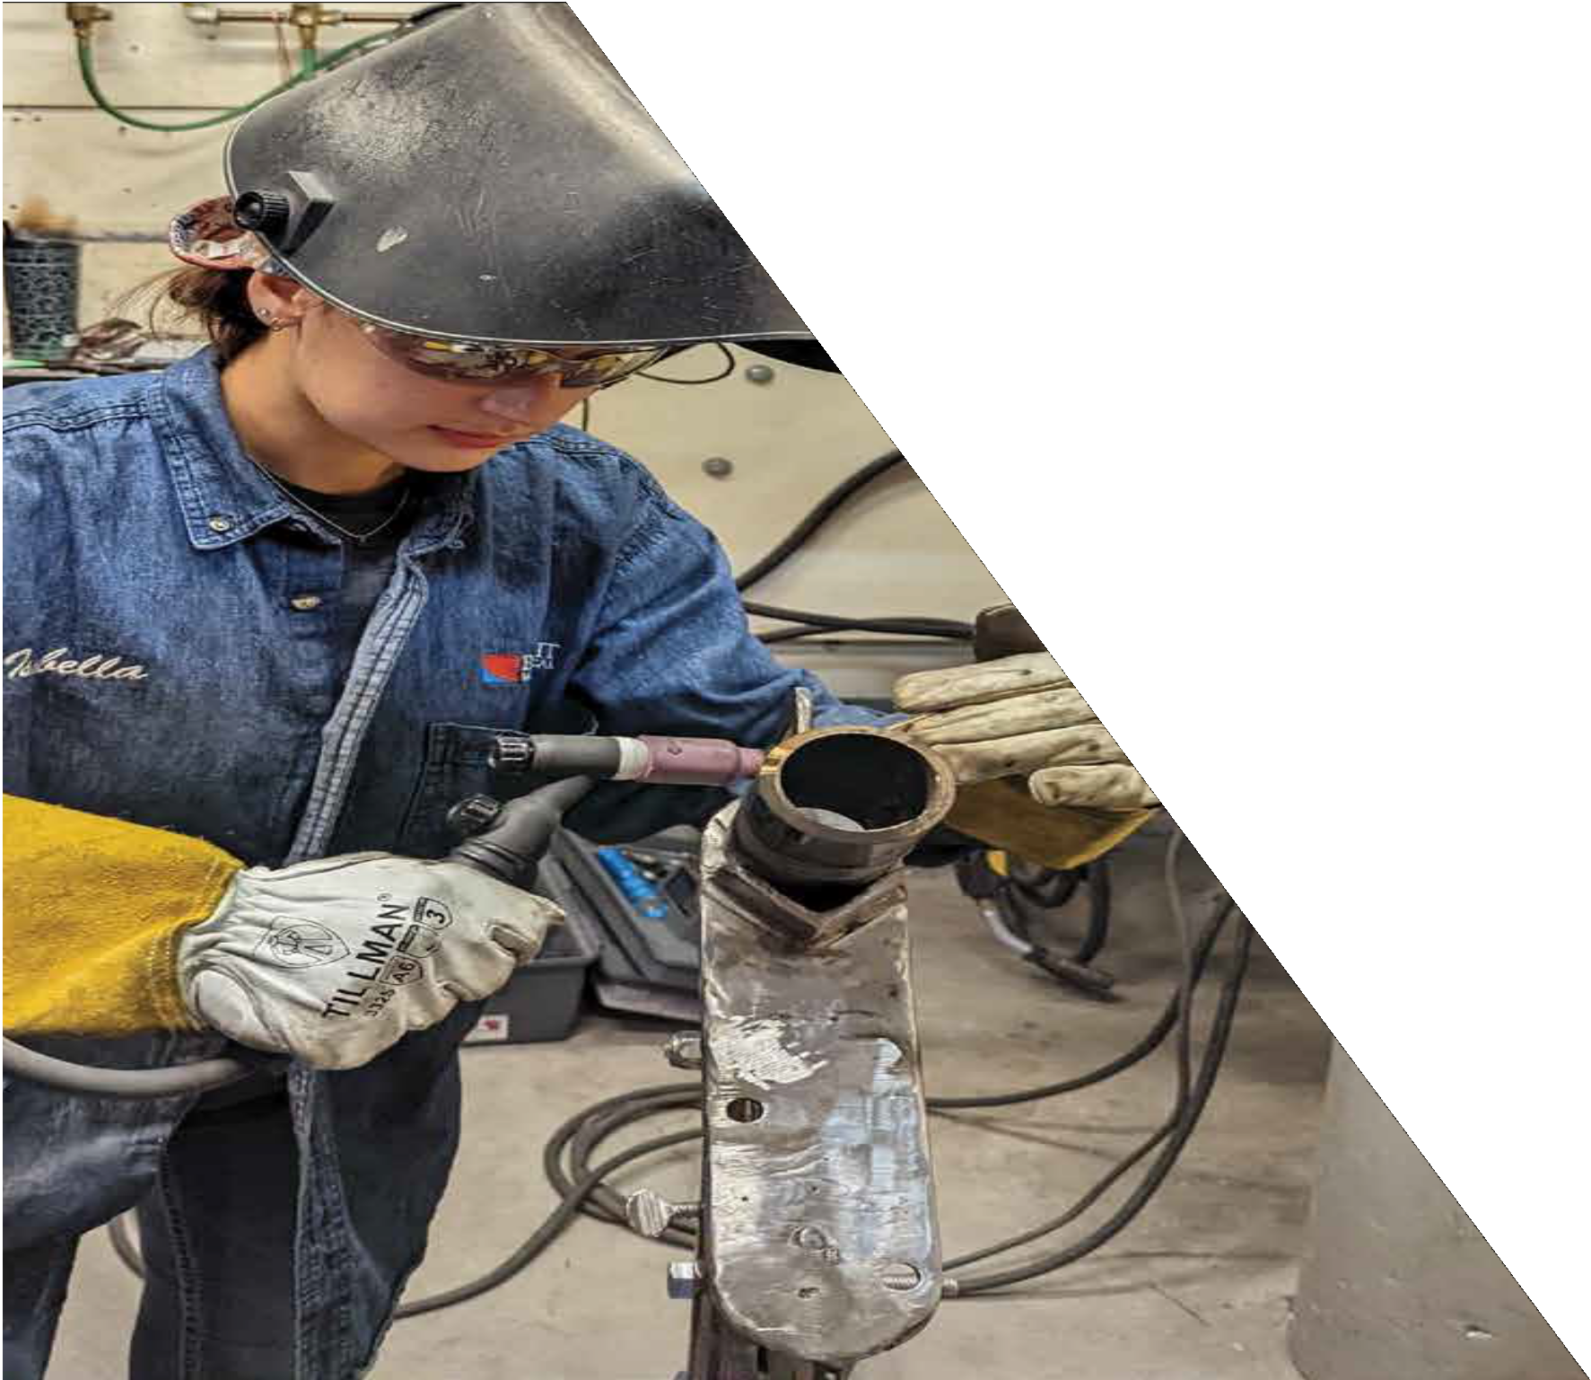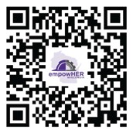

Contact Ashley at [ashley@ua400.org](mailto:ashley@ua400.org) or call 920.462.0408 with any questions or to RSVP