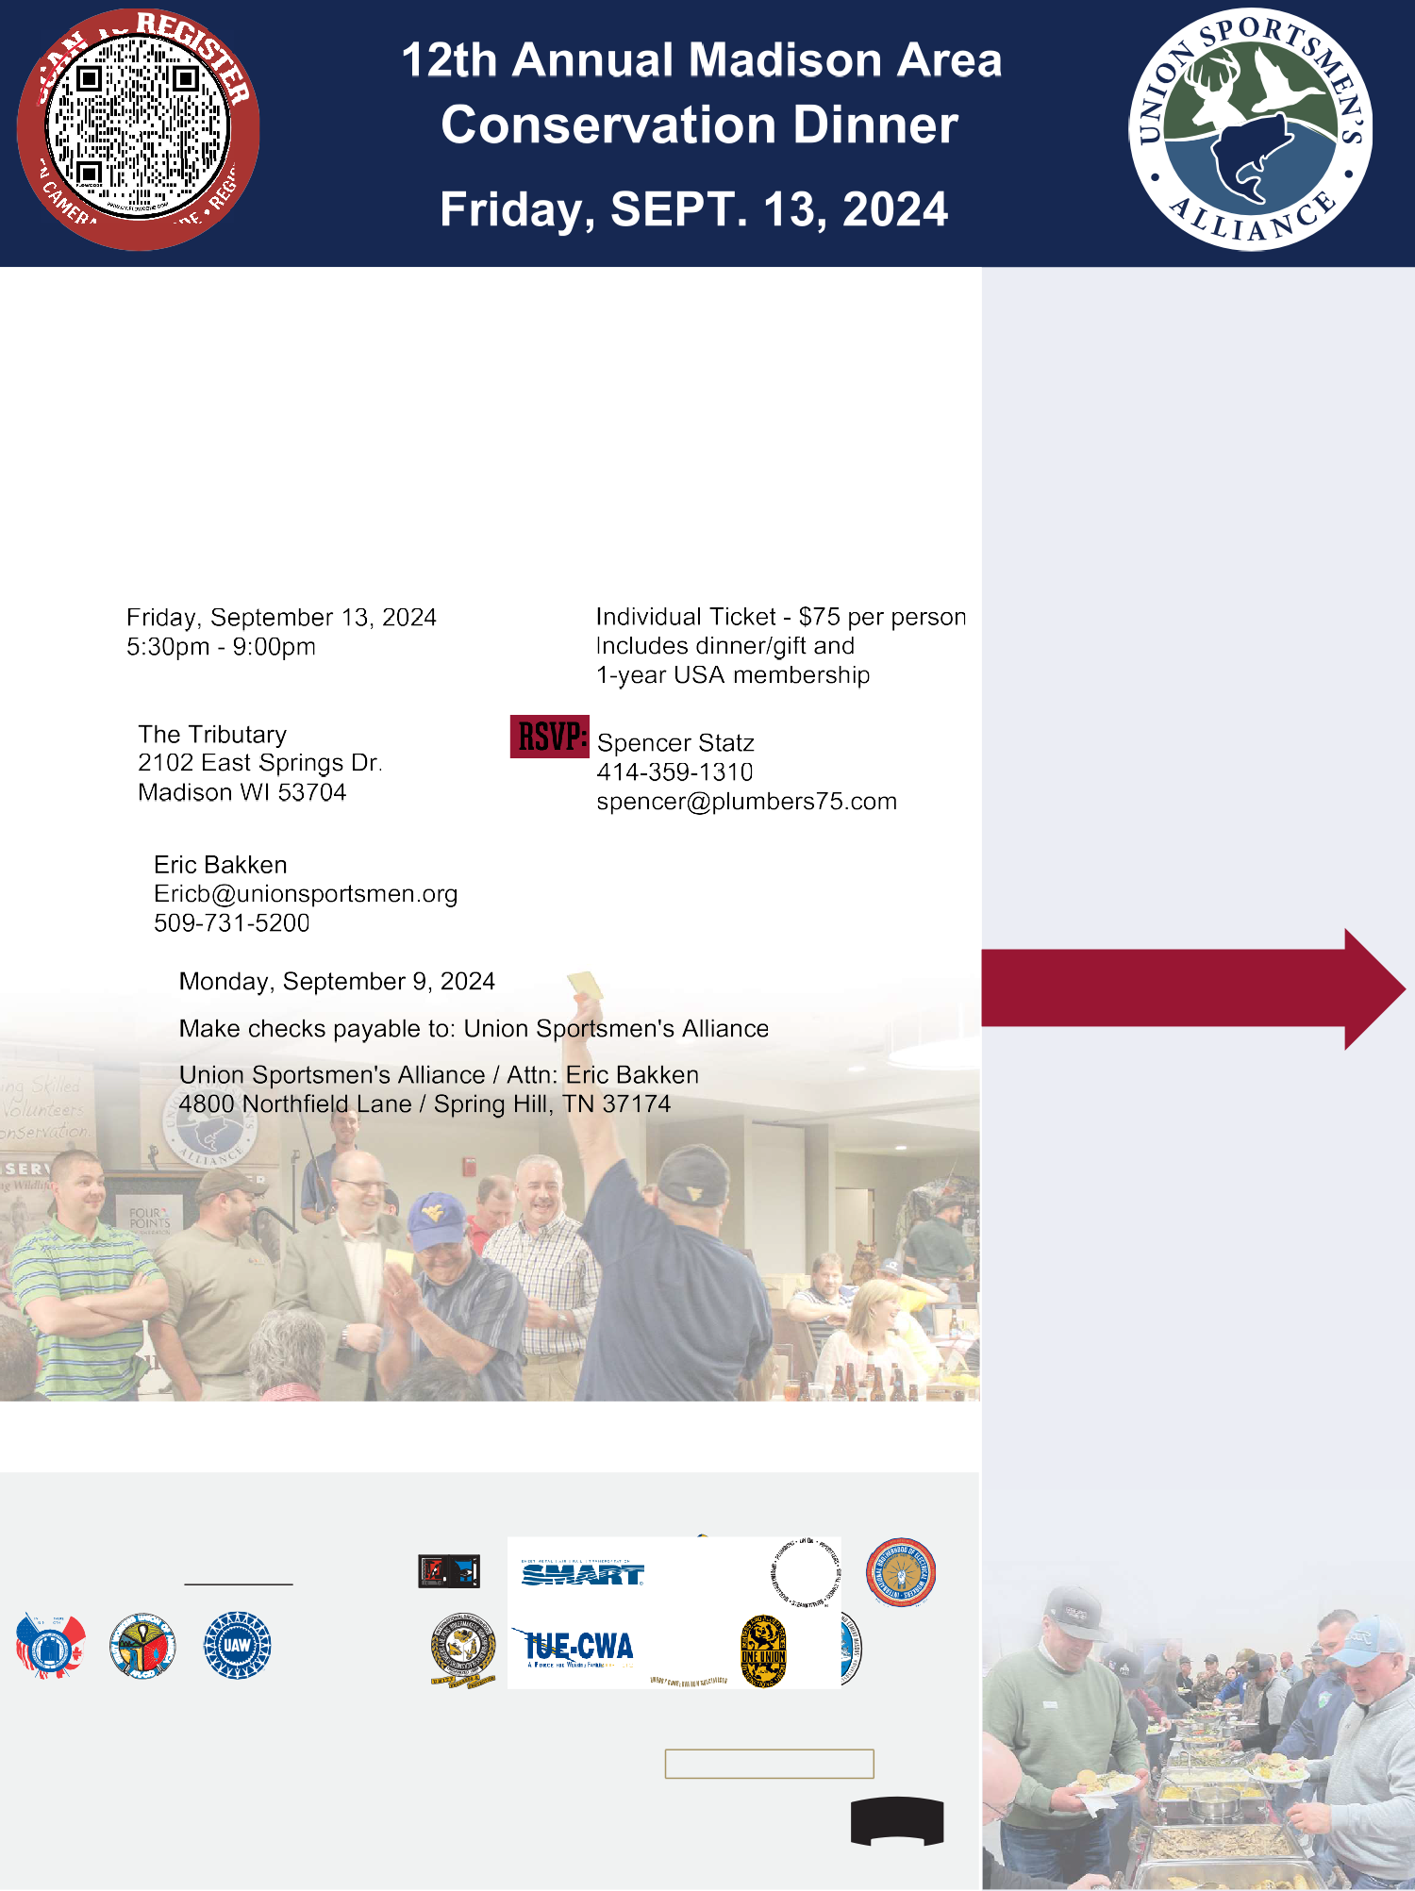

**-tO**

0

*a::*

*-9.q* • SCAN co0(c,

|  |  |
| --- | --- |
| **DINE FOR CONSERVATION**  ***Your support helps the USA raise funds and recruit volunteers* to**  ***complete conservation projects where you live, work and recreate!***  EVENT DETAILS  WHEN: COST:  WHERE:  USA CONTACT:  DEADLINE: PAYMENT: MAIL TO: | **SPONSORSHIP**  **LEVELS**  **PLATINUM SPONSOR**  $10,000 *(5 table prizes)*  **GOLD SPONSOR**  $5,000 *(3 table prizes)*  **SILVER SPONSOR**  $3,500 *(2 table prizes)*  **BRONZE SPONSOR**  $1,750 *(1 table prize)*  **VETERAN SPONSOR**  $2,000 *(1 table prize) We will fill your table with veterans on your behalf.*  Please provide table prize choice on reverse.  ***NEW FOR 2024* MEAL SPONSORSHIP**  **$5,000 Sponsorship Includes:**   * Event-wide recognition * 2 tickets to attend * Cups with your logo at every seat * Sign at start of food lines   *Call to secure* |
| **The mission of the USA is to unite the union community through conservation to preserve North America's outdoor heritage.** |
| **CHARTER UNIONS**  **AFL-CIO** , : llD !I  -= /  **LiUNA!**  **NFLPA**  **NATIONAL** & **FOUNDING PARTNERS**  **AFL-CIO llico** PROVOS T * UMPHREY -  **1:1 UNIO**\***N** PLUS **Humana. UUNIIOGN BUCK**  ..,. ,. ..  Bankofl.ehor INSURANCE  GROUP |

Platinum Sponsor - $10,000 *(5 Table Prizes)* x _

**CHOOSE 5 PRIZES** □Henry .22 _ ■Barnett Crossbow _ ■Orea Cooler _

Gold Sponsor - $5,000 *(3 Table Prizes)* x _

**CHOOSE 3 PRIZES** ■Henry .22 _ ■Barnett Crossbow _ ■OreaCooler _

Silver Sponsor - $3,500 *(2 Table Prizes)* x _

**CHOOSE 2 PRIZES** ■Henry .22 _ ■Barnett Crossb ow _ ■Orea Cooler _

Bronze Sponsor - $1,750 *(1Table Prize)* x _

**CHOOSE 1 PRIZE** ■Henry.2 2 _ ■Barnett Crossbow _ ■Orea Cooler _

Veteran Sponsor - $2,000 *{1TablePrize)x_*

**CHOOSE 1 PRIZES** ■Henry .22 _ ■Barnett Crossb ow _ ■Orea Cooler _

TABLE SPONSOR CONTACT:

Name Phone _

~~■~~

Email

Will you be filling your table?

ves

_

Henry Classic Lever Action .22

Hunter STR Crossbow

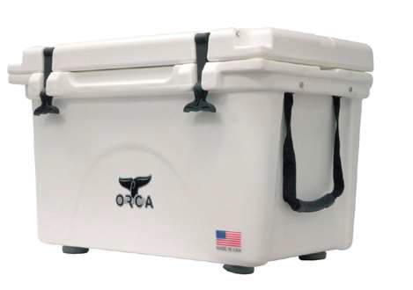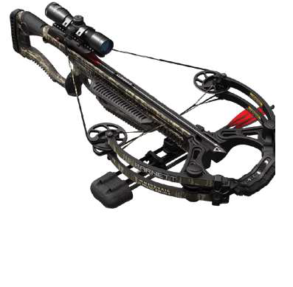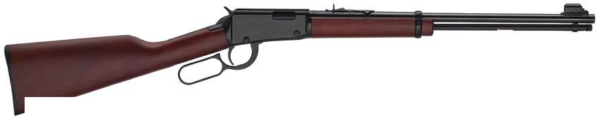

**SPONSOR A TABLE**

table prizes (your choice).

All table sponsors will receive dinner and gifts for 1O guests. Plus, your union or company name will be featured in our event agenda.

***Here are a few ways you can help to support conservation.***

**EXCLUSIVE UNDERWRITING OPPORTUNITIES *Sponsorshipopportunitiesarelimited.***

All underwriters will be prominently recognized in the dinner agenda and event presentation, which runs the entirety of the event.

# MEAL SPONSORSHIP - $5,000

The New Meal Sponsorship includes event wide recognition for being the food sponsor, 2 tickets for your staff to attend, cups with your logo at every seat in the house and signs at the start of the food lines. *Call to secure.*

# BONUS DRAWING - $1,000

USA's wildly popular Bonus Table, which includes thousands worth of outdoor gear including 3 guns (min.), is available for an exclusive sponsorship for $1,000. Your name (local/company/individual) will be recognized on Bonus Table -specific signage.

# USA GUN OF THE YEAR [GDTY] - $750

Stand out in the crowd and get max exposure! Your name (local/company/individual) will be recognized on GOTY-specific signage and mentioned throughout the cocktail hour and gaming period. ONLY 1 GUN OF THE YEAR sponsor available.

# EVENT AGENDA SPONSOR - $500

Be front and center for all to see! Your name (local/company/individual) will be included on the front page of the event agenda placed at every seat!

# DRAW DOWN LIVE AUCTION GUN

Proudly sponsored by USA Founding Partner in 2024

**DEADLINE FOR ALL SPONSOR SIGNAGE: August 23, 2024**

Eric Bakken 509-731-5200

**CONTACT:** [Ericb@unionsportsmen.org](mailto:Ericb@unionsportsmen.org)

The Union Sportsmen's Alliance mission is to unite the union community through conservation to preserve North America's outdoor heritage. Financial and other information about our charity's purpose, programs, and activities can be obtained by contacting Isaac Llanes, Director of Finance, 4800 Northfield Lane, Spring Hill, TN 37174, 615-831-6796. Contributions are deductible for federal income tax purposes in accordance with applicable law. Registration in a state does not imply endorsement, approval, or recommendation of Union Sportsmen's Alliance by the state.